**Long-Term Care Exercise**

**You will need:**

Appendix A_LTC Surveillance Database, available on the IPAC Canada [webpage](https://ipac-canada.org/surveillance-statistics-resources.php) for download (blank), screenshot for the purposes of this exercise provided on page 5.

Resident Respiratory Tract Infection Line List on pages 6-7.

Resident Dining Room Seating Arrangement on page 8.

Surveillance Definitions of Infections in Canadian Long Term Care Facilities, available on the IPAC Canada webpage. Relevant excerpts are provide on pages 9-10.

**Questions:**

**1. Data cleaning**

Review the Appendix A_LTC Surveillance Database and list 2 data errors. How would you correct them?

Click here to enter text.

**2. Applying case definitions**

You are an ICP at a long-term care home (ABC Care) and have been asked to review the resident line list on pages 6-7 to determine whether any of the residents meet the IPAC Canada surveillance definitions, on page 9, for upper respiratory tract infection or pnuemonia.

Which resident(s) meet the case definition for an upper respiratory tract infection?

Click here to enter text.

Which resident(s) meet the case definition for pneumonia?

Click here to enter text.

**3. Epi-curve**

Study the October 2022 respiratory tract infection line list on pages 6-7. Manually plot the onset dates for all cases against the number of cases observed on each date to generate an epi-curve.

**4. Rate calculations**

It is the end of the month and you are reviewing respiratory tract infection surveillance data from October. Your observations include:

* There were 150 residents present in the facility for the full month of October
* A total of 12 residents had new onset of upper respiratory tract infection in the month of October
* A total of 7 residents developed pneumonia in the month of October

Hint: Rate = (X/Y)*k

What is the total number of resident days for the month of October?

Click here to enter text.

What is the incidence rate of upper respiratory tract infection for the month of October per 1,000 resident days?

Click here to enter text.

What is the prevalence rate of pneumonia in the month of October per 100 residents?

Click here to enter text.

**5. Examining epi links - Floor plan**

Examine the dining room floor plan on page 8. Compare this to the resident line list on pages 6-7. What do you notice?

Click here to enter text.

**6. Data to action**

What are the next steps you would take based on your observations? Consider if further investigation is needed, if infection prevention and control interventions are warranted, etc.

Click here to enter text.

**7. Reviewing annual data**

The graph above depicts a summary of all the infections in your facility over the past year. You have been asked to prepare an annual summary report for unit nursing staff and administrations, what information would you choose to highlight and what images/visuals would you consider including?

Click here to enter text.

**8. Benchmarking**

To further understand the observed increase in respiratory illness in your facility in the fall of 2022, and whether this was unusual for your facility, your manager has asked you to internally benchmark your data. Which of the following is most appropriate:

1. Comparing the data for 2022 to 2021 (full year)
2. Comparing the data from October-December of 2022 (fall) to January-March of 2022 (spring)
3. Comparing data from October-December of 2022 (fall) to the same time period in 2021

**Appendix A – LTC Surveillance Database (****screenshot)** (back to Q1a)

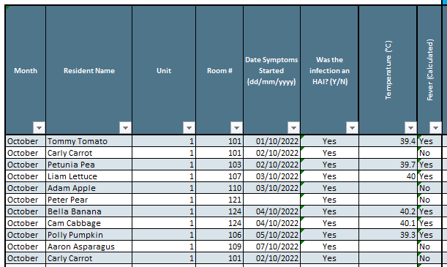

**Resident Respiratory Infection Line List without Infections Identified** (back to Q1b, Q1c or Q1e)

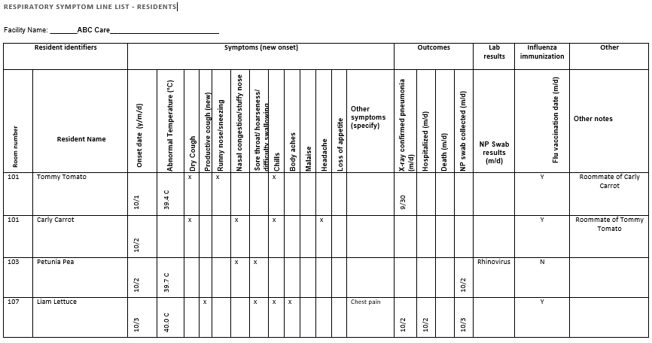

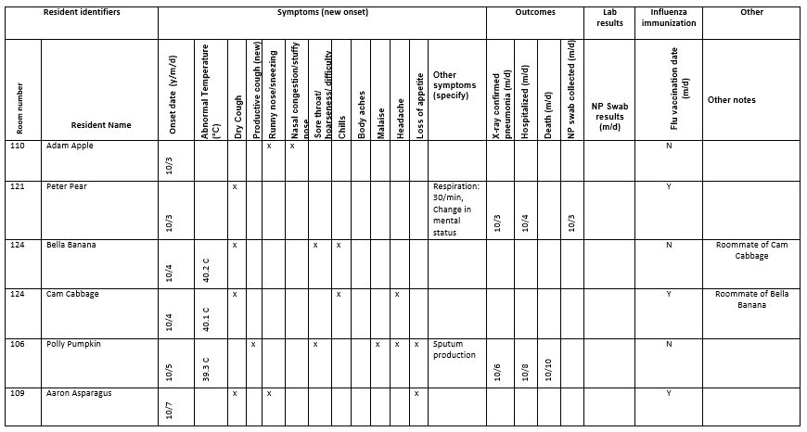

**LTC Facility Dining Room Floor Plan** (back to Q1e)

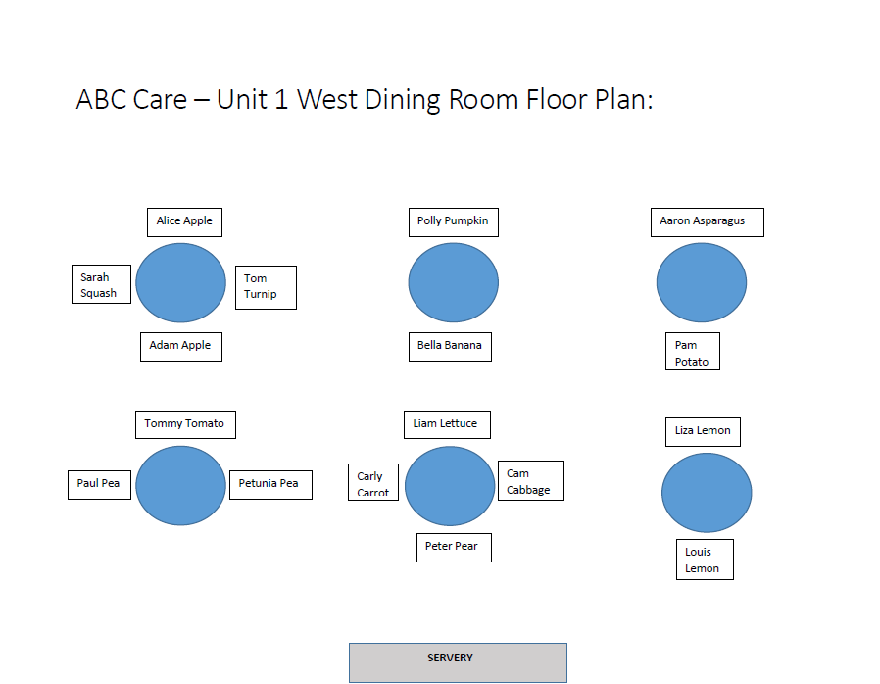

**IPAC Canada Long-Term Care Infection Surveillance Definitions Excerpt** (back to Q1b)

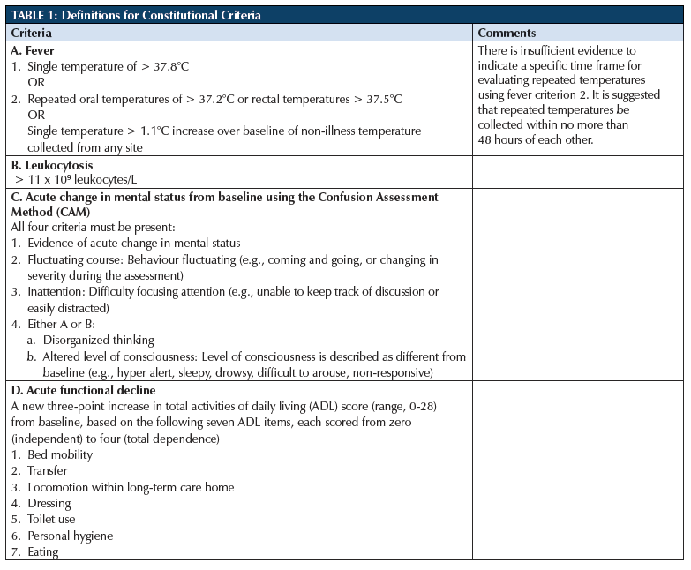

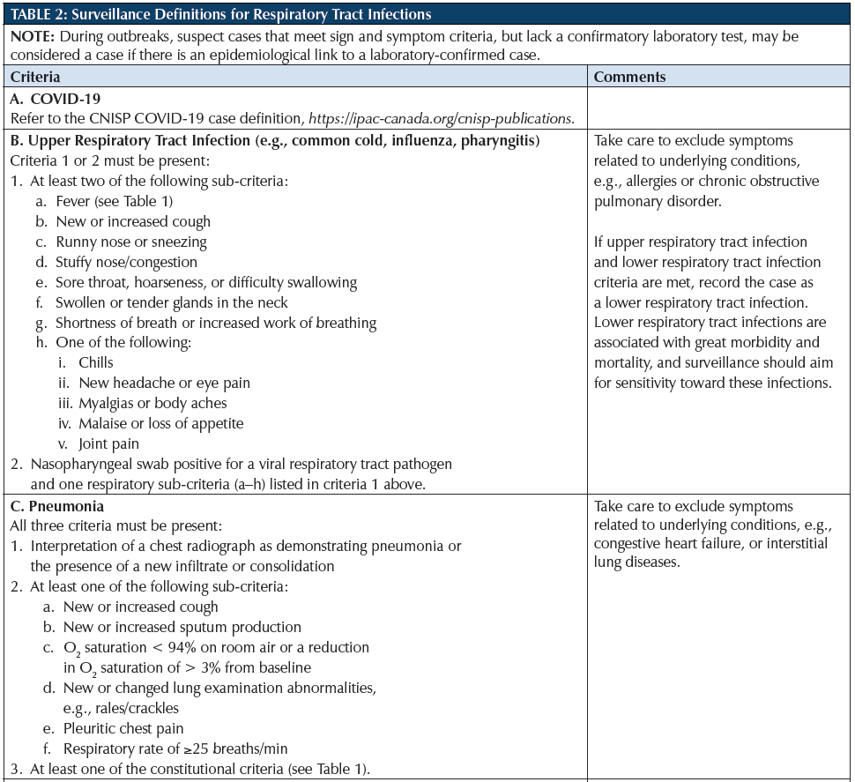

**Additional Practice**

**Calculating Resident Days**

1. There are 120 residents in your LTCF during the month of June. How many resident days are there in June?
2. There are 50 residents living in your LTCF throughout the 2022 calendar year. How many resident days are there in 2022?
3. There are 100 residents living in your LTCF throughout the month of October and November. There are 102 residents in your LTFC throughout the month of December. How many resident days are there in the last quarter of the year?

**Calculating Rates**

1. There are 120 residents in your LTCF during the month of June. Five residents developed a healthcare associated COVID infection. What is the COVID infection rate per 1,000 resident days in June?
2. There are 50 residents living in your LTCF throughout the 2022 calendar year. Seven residents developed CDI. What is the CDI rate per 10,000 resident days in 2022?
3. There are 100 residents living in your LTCF throughout the month of October and November. There are 102 residents in your LTFC throughout the month of December. Three residents developed CAUTI during the quarter. There were 1,500 catheter days. What is the incidence of CAUTI during the quarter per 1,000 catheter days?
4. There are 150 residents living in your LTCF in January. Twelve residents developed influenza. What was the incidence of influenza per 1,000 resident days?
5. There is a norovirus outbreak in your LTCF which has 20 residents and 6 staff. Eleven residents and 2 staff are ill. What is the attack rate percentage of norovirus in residents and staff?

**Answers are provided on Page 13**

**Additional examples** can be found in Boxes 11 through 14 of the Ontario Agency for Health Protection and Promotion (Public Health Ontario), Provincial Infectious Diseases Advisory Committee, Best practices for surveillance of health care-associated infections in patient and resident populations. 3rd ed. Toronto, ON: Queen’s Printer for Ontario; 2014: [https://www.publichealthontario.ca/-/media/ Documents/B/2014/bp-hai-surveillance.pdf?rev=9e7eb19b6140410faed32a5dafed8f3e&sc_lang=en](https://www.publichealthontario.ca/-/media/%20Documents/B/2014/bp-hai-surveillance.pdf?rev=9e7eb19b6140410faed32a5dafed8f3e&sc_lang=en)

**Answers**

**Calculating Resident Days**

1. 120 residents x 30 days in the month of June = **3,600** resident days in June
2. 50 residents x 365 days in the year = **18,250** resident days in 2022
3. 100 residents x 31 days in October = 3,100 resident days in October

100 residents x 30 days in November = 3,000 resident days in November

102 residents x 31 days in December = 3,162 resident days in December

Total resident days of 3,100+3,000+3,162 = **9,262** in the last quarter of the year

**Calculating Rates**

1. (5 HAI COVID cases / 3,600 resident days in June) x 1,000 resident days = **1.39** HAI COVID cases per 1,000 resident days
2. (7 CDI cases / 18,250 resident days in 2022) x 10,000 resident days = **3.84** CDI cases per 10,000 resident days
3. (3 CAUTI cases / 1,500 catheter days) x 1,000 catheter days = **2.00** CAUTI cases per 1,000 catheter days
4. 150 residents x 31 days in January = 4,650 resident days

(12 influenza cases / 4,650 resident days) x 1,000 resident days = **2.58** influenza cases per 1,000 resident days

1. (11 sick residents / 20 total residents) x 100 = **55%** attack rate for residents

(2 sick staff / 6 total staff) x 100 = **33%** attach rate for staff